**Curriculum Vitae**

**Personal Information:**

**Ali Jaffar Abdullah AlShaikh**

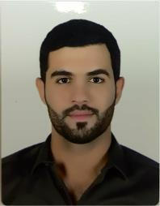

* C.P.R No:960508350
* Nationality: Bahraini
* Date Of Birth: 31/5/1996
* Marital Status: Single
* Address: Home: 480, Avenue: 613, Jannusan: 506
* E-mail: alialshaikh196@gmail.com
* Mobile: 32333407

**Objectives:** Seeking a challenging career with a progressive organization that provide an opportunity to contribute and capitalize my technical skills & abilities in the field of accounting

**Education:**

**Duration Qualification Institution**

2011-2014 Secondary School Certificate Al-Naim Secondary School

2014-2019 B.Sc. in Accounting-Finance University Of Bahrain

(Graduated on 14/1/2019)

**Work experience:**

**Duration Position Establishment**

15 July-13 September Collector Bahrain credit BCFC

**Duration Position Establishment**

2013-2019 Organizer Arabian Exhibition Management

**Skills & Abilities:**

Languages:

* Arabic: Mother tongue.
* English: Speaking, Writing & Reading.

Computer Skills:

* In depth knowledge of working with computer.
* Excellent communication skills.
* Microsoft Office Programs

**References:**

Accounting Department, University Of Bahrain, Sakhir.

Multiple Loans Manager, Ali Isa , contact: 33221239